
a
Company
Logotype

Cone Beam Computed Tomography- Report



Porur Dental X-rays & CBCT

Patient Name : Dr. K. Vengada Krishnan | Date of Report : 06.08.2024
Age/ Gender : 49 years/ Male | Region of Interest : CBCT Sectional Maxilla
Referring doctor: Dr. Vigneshwar | Indication : Implant assessment
Clinical Notes: Nil
PATIENT INFORMATION

CBCT- Sectional Maxilla provided
CBCT – IMAGE DETAILS

RADIOGRAPHIC INTERPRETATION

- The maxillary alveolar ridge is present with normal trabecular pattern.
- In relation to 16, presence of hyperdense restorative material within the pulp canals extending upto the apical third of the roots is evident. Presence of mild hypodensity in the periapical aspect of disto buccal root is also evident.
 | 16 region
Sub-Crestal (in mm) | 12.08
Mid- Crestal (in mm) | 12.87
Distance between the alveolar ridge and floor of the maxillary sinus (in mm) | 7.86
IMPLANT ASSESSMENT
RADIOGRAPHIC IMPRESSION

- Root canal treated tooth: 16.

Kindly correlate with clinical findings


IMAGES FOR REFERENCE

RECONSTRUCTED PANORAMIC VIEW

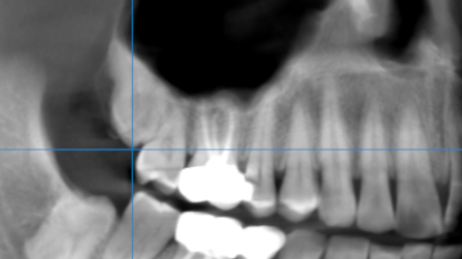

3-DIMENSIONAL VIEW

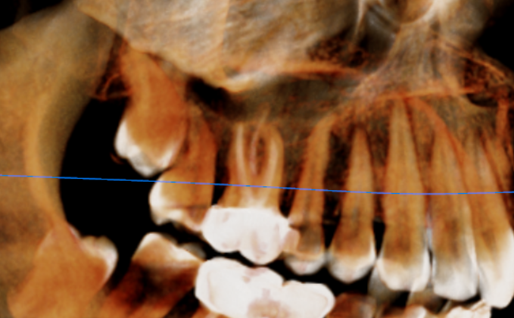

CROSS SECTIONAL VIEW

16 region | 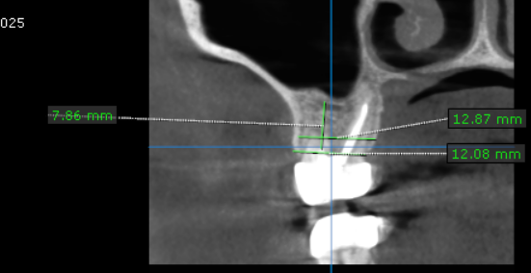

**** End of report ****

